
E-13, UPSIDC Site-IV, Kasna Road, Greater Noida - 201308, India
Phone: +91.120.4296878 | Website: www.khuranaandkhurana.com www.iiprd.com
Email: info@khuranaandkhuraana.com | iiprd@iiprd.com
Indian Offices: Noida | New Delhi | Bangalore | Mumbai | Pune | Mumbai | Hyderabad | Jalandhar | Chennai
International Offices: US |Bangladesh | Sri Lanka | Malaysia | Vietnam | Myanmar | Nepal | Malaysia

INVENTIVE DISCLOSURE - CONFIDENTIAL

1. | Title of the Invention
 | Smart Spice Dispenser System using 8051 Microcontroller and Arduino
2. | What is the Technical Field of Invention?
This invention belongs to the field of embedded systems, automation, and smart kitchen technology.
- Problem: Manual spice dispensing leads to inaccurate measurements, inconsistent taste, and increased cooking time.
- Solution: An automated system using microcontrollers, load cell, and servo motors to dispense precise quantities of spices with minimal human effort.
- Purpose: To ensure accuracy, consistency, and efficiency in cooking processes.

3. | Search Terms
 | Smart dispenser, automated spice system, load cell measurement, HX711 module, Arduino servo control, kitchen automation, embedded system dispensing.
4. | Background of the Invention (Present state of Art)
Present Technologies:
- Manual measuring spoons
- Basic automatic dispensers (without weight feedback)
- Industrial packaging machines

Limitations:
- Human error in measurement
- Lack of precision
- No real-time feedback
- Time-consuming process

5. | Prior Art
 | Existing systems include automatic dispensers and weighing machines separately. Some smart kitchen devices exist but lack integrated control of dispensing + measurement + display in a compact system.
6. | Has the work filled a major gap in the prior art? If yes, a brief description of this gap.
Yes. Existing systems do not provide:
- Integrated dual-controller system (8051 + Arduino)
- Real-time weight feedback with automatic dispensing
- Low-cost implementation for household use

7. | What are the components of the Invention?
- 8051 Microcontroller (main controller)
- Arduino Uno/Nano (servo control)
- Servo Motors (5 units)
- Load Cell (weight sensing)
- HX711 ADC Module
- I2C LCD Display
- Push Buttons (A–E + TARE)
- Power Supply & Wiring
8. | How does the Invention work?
- System initializes LCD, UART, and HX711
- User presses TARE → calibration done
- Button A–E pressed
- 8051 sends signal via UART
- Arduino receives and activates corresponding servo
- Spice is dispensed
- Load cell measures weight
- LCD displays real-time weight
9. | Novelty of the Invention/Inventive Step of the Invention
- Integration of 8051 + Arduino dual-controller architecture
- Real-time feedback loop using load cell
- Automated dispensing with precise weight control
- Low-cost and compact smart kitchen solution
10. | What are the advantages and improvements over the existing methods/devices?
- High precision dispensing
- Consistent cooking results
- Reduced human effort
- Faster operation
- Cost-effective compared to industrial system
11. | Do you have in your mind as a researcher/inventor some ideas as to what are the various other/alternative forms in which your Invention can be depicted or utilized, in addition to one basic embodiment that has been described above?
- Mobile app-controlled dispenser
- Voice-controlled system
- IoT-based remote monitoring
- AI-based recipe automation
12. | Please provide final CAD images/line diagrams of the final prototype which illustrates all the essential elements of the invention.
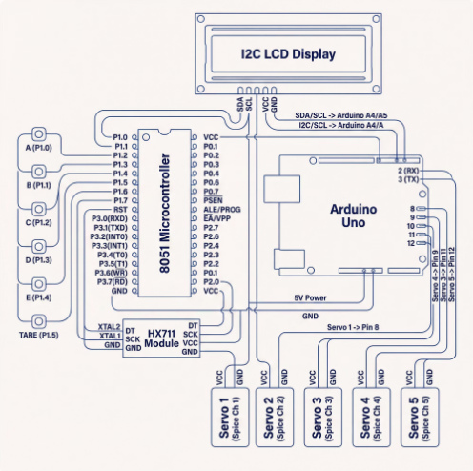
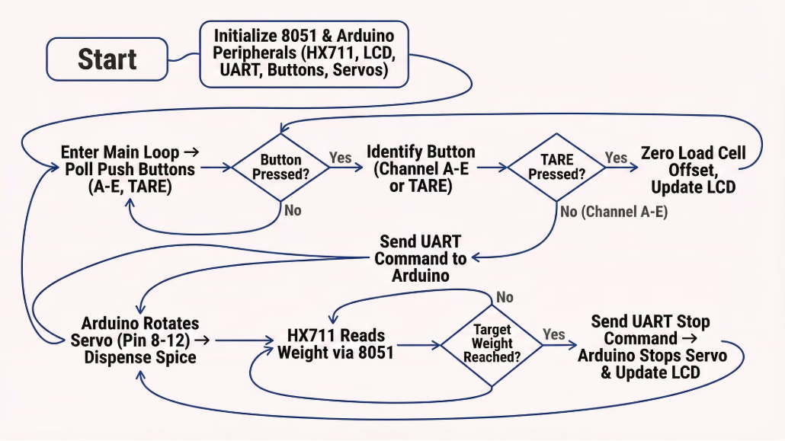
13. | Brief description from the researcher/inventor in his own words explaining the images/ drawings.
The diagrams illustrate:
- Communication between 8051 and Arduino
- Servo-based dispensing mechanism
- Load cell feedback system
- Display output via I2C LCD

14. | Please give complete description including the working examples/ working methodology of the invention.
- Calibration using known weight
- Weight calculation formula:
weight = (reading - x0) × CAL_WEIGHT / (x1 - x0)
- UART communication for control signals
- Servo rotation controls spice flow
- Continuous weight monitoring ensures accuracy
15. | Please provide details of experiments conducted /third party validation data if any.
- Successfully tested for accurate dispensing
- Real-time weight display achieved
- Smooth communication between controllers
16. | Please provide details of any public disclosure done/ any publication made.
 | No public publication has been made
17. | What is the stage/level of development of the Invention?
- At a basic conceptualization stage?
No, Completed.
- Completed and results validated?
Yes, Completed and results validated.
18. | What are the aspects of your disclosure that you want to claim/monopolize? (Proposed Claims)
- Automated spice dispensing system using dual microcontrollers
- Integration of load cell with servo control for precise output
- Real-time feedback-based dispensing mechanism

19. | - Have you conducted novelty/inventiveness search for your invention? If yes, what are the databases /references used by you? What are the search results?
S.No | Reference | Existing Idea | Our Invention
1 | Manual measuring tools | No automation | Fully automated
2 | Basic dispensers | No weight feedback | Real-time weight
3 | Industrial machines | Expensive | Low-cost solution

20. | Do you feel that a person of “average” skill (not-extraordinary skill) in your area of technology would have arrived at your invention with existing knowledge in public domain? If no, what could be the reasons for the same?
A person with average skill would not easily combine:
- Dual controllers
- Real-time weight feedback
- Automated dispensing system
Hence, invention is non-obvious.

21. | Kindly provide broad workable ranges for all the parameters involved in your invention.
- Weight range: 0–1 kg (depending on load cell)
- Servo angle: 0°–180°
- Voltage: 5V system
- UART baud rate: ~9600
22. | Commercialization Data (at least a minimum of 2 companies must be provided and preferably up to 5)
Potential companies:
- Philips India
- Prestige (TTK Group)
- Bajaj Electricals
- Usha International
- Havells India
23. | Provide available data or information on market potential/size, adoption trends, industry analysis, and projected growth.
Year | Market Size | Growth Drivers | Devices
2025 | Growing | Smart homes | Auto dispensers
2030 | High | IoT kitchens | AI cooking devices

24. | Please provide the names of the inventors involved in the Invention
Vansh Kukkar
Krish Kumar Kedia
Ronit Vishwakarma
Om Patil
Prashant Kumar Moharana
25. | User Information
a. Users: Home cooks, restaurants, food industries
b. Age group: 18–60 years
c. Benefits: Accuracy, convenience, time-saving
d. Cost Advantage: Cheaper than industrial systems
26. | What is Technology readiness level of your invention? (Tick the appropriate TRL)
TRL Level | Description for Your Project
TRL 1 | Basic principles of automation, weight measurement using load cell, and microcontroller communication were studied and understood.
TRL 2 | Concept of a Smart Spice Dispenser system using 8051, Arduino, servo motors, and HX711 module was formulated.
TRL 3 | Experimental proof of concept achieved by testing individual modules like servo motor control, load cell readings, and LCD display.
TRL 4 | System validated in laboratory setup by interfacing 8051 with Arduino, HX711, I2C LCD, and servo motors successfully.
TRL 5 | Integrated system tested in a simulated kitchen-like environment showing accurate dispensing and weight measurement.
TRL 6 ✅ | A working prototype demonstrated in a relevant environment with full functionality: button input → UART communication → servo dispensing → weight measurement → LCD display.
TRL 7 | System prototype demonstration in real operational environment (not yet implemented in actual kitchen/industry).
TRL 8 | Complete system qualification with optimized hardware and enclosure (future work).
TRL 9 | Fully deployed product in commercial kitchens or industry (future scope).

27. | Any additional notes or remarks.
 | No

